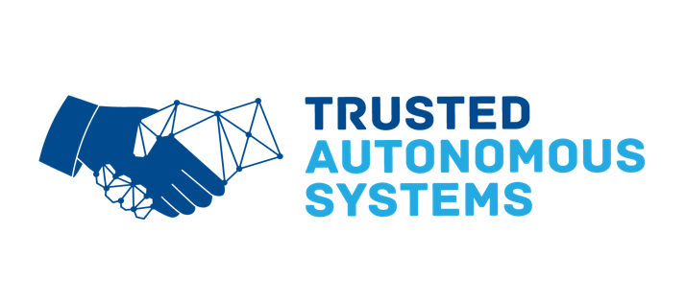
Draft Program
(Full Program, Abstracts and Updated Speaker Bios will be distributed a week prior to the Symposium via a Carillion Conference Management Portal).

Tuesday 20 April - Concepts

Lunch & Registration
1330 Conference Opening
- TAS CEO, Professor Jason Scholz
- Acting Director-General QLD Department of Tourism, Innovation and Sport, Mr John Lee
Future Concepts
- Technology in Warfare, Major General Mick Ryan AM, Acting Chief of Joint Capabilities
#Live Stream

- Australian Strategic Policy Institute, Dr Marcus Hellyer
- Research Innovation, RMIT Associate Deputy Vice Chancellor Research Professor Swee Mak
- Defence Science & Technology
Role of RASAI in respective Services & Domains
- Royal Australian Navy, Captain Adam Allica, Director Warfare Innovation Branch
- Australian Army, COL Robin Smith OBE, Robotic and Autonomous Systems Implementation Coordination Office (RICO) #Live Stream
- Royal Australian Air Force, Group Captain Mike Burgess-Orton, Plan Jericho
- Space (SmartSat)
1800 for 1830 onwards Symposium Dinner
- Dinner Speaker – QLD Deputy Director-General for Innovation, Dr Sarah Pearson
#Not Broadcast Virtually

Wednesday 21 April - Test & Evaluation

0845 Site Visit
- Australian Institute of Marine Science / Reef Works (Maritime Test Range)
#Not Broadcast Virtually

Lunch

1330
Ethics & Law
- Briefing, Presentations and Panel on Ethics Program (including UQ Law and the Future of War Team) Chair – TAS Chief Scientist Dr Kate Devitt
Assurance of Autonomy
- Briefing, Presentations and Panel on Assurance Activities (including UAV Flight Test Range) Chair, Director Autonomy Accreditation Rachel Horne
1700-1900 Networking Function
(including Open Mike for attendees to brief on their role, company)

Thursday 22 April - Operationalisation

0845
- Australian Army, COL Robin Smith OBE, (RICO), Update on the Army Robotics eXposition (ARX)
- Partnering for Effect – LTCOL Kelwyn O’Brien, Dismounted Combat Program
- Industry as a Partner – LTCOL Scott Holmes

- Static Display – Army, Combat Training Centre (CTC)
#Not Broadcast Virtually

- Completed Trusted Autonomous Systems Projects (Presentation x 2 Projects)
  - Athena AI, Dr Stephen Bornstein, Cyborg Dynamics
  - Director Phantom Works International, Dr Emily Hughes, Boeing

Lunch

Optional Activity - Assurance of Autonomy – Body of Knowledge Workshop
#Not Broadcast Virtually

